**Semi-supine or Active Rest**

Illustration from *alexander technique* by Joe Searby, Duncan Baird Publishers,: 2007

Lying down gives your body a rest from the usual habitual tensions. You will become quieter and calmer. Your breathing will be freer and there will be less pressure on your internal organs. It allows muscles to release unnecessary tension and the spine to return to its full length. It is where you explore the connection between mind and muscle. As with any skill it becomes easier with practice, and should become enjoyable and something to look forward to. Try to practise daily for around 10 minutes – any time is suitable. It is also useful if you are tired from activities such as gardening or prolonged sitting. The more often you practise the quicker your body will respond. Listen to music or the radio if you wish and if it makes it easier to do.

1. Lie on your back on a carpet or exercise mat (a bed is too soft) with your knees bent and the soles of your feet flat. Your feet should be hip-width apart and as close to your seat as is comfortable. Try not to let your knees float apart too much but don’t keep your knees together.
2. Rest your head on a stack of books so that it is supported and your neck is unsupported. The books should be 2 – 4 inches (5 – 10 cm) high. If your head is tilting backwards add more books. If you are not sure, slightly too many books is better than too few.

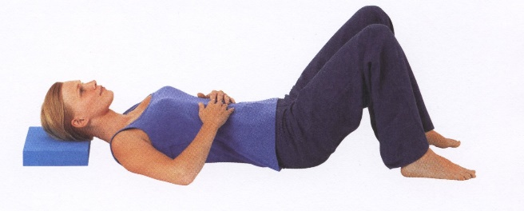.

1. Your upper arms rest on the floor. Your hands rest palm-downwards on your tummy. The fingers do not touch but are straight. Your knees will be pointing to the ceiling, as shown in this picture. Soften your fingers and wrists.
2. Your tongue should rest at the bottom of your mouth with the tip just touching the inside of the lower teeth. Your back teeth are not touching or clenched. Relax the eyes, jaw and forehead….smile. If possible, breathe through your nose and allow the breath to flow in and out naturally without interference.
3. Notice the contact of the floor below your feet, pelvis, shoulders and elbows. Let the surface support you.
4. Keeping your eyes open both help to keep your sense of balance engaged throughout. You should avoid "going inside yourself"; the idea is to expand your field of awareness, not deliberately to narrow it! Use your eyes, ears and other senses to inform you constantly about your surroundings.

The position, gravity (your resting weight) and your intention to "leave yourself alone" all combine to create a light stretch throughout your back. Think in terms of lively stretch and expansion rather than the sort of floppy relaxation that may result in your becoming heavy and unresponsive.

Download 15 minute talk through on Youtube 

When you want to get up, don't sit up, roll over slowly first. Be aware of the head leading and the spine lengthening as you get up and avoid overtightening the neck muscles. Be aware that you may feel a little light-headed when you first get up.

www.kimcant-alexandertechnique.co.uk 